F118(UDC) 可加减計數器 UP/DOWN counter Step 5, Availability All FP0s

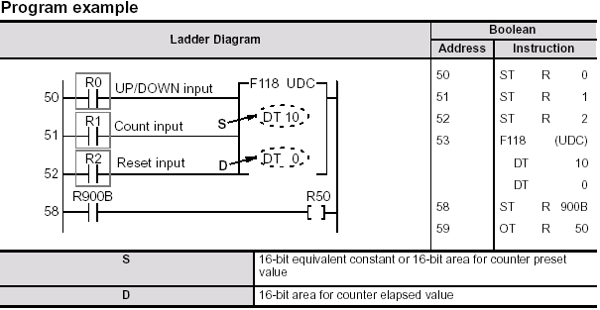
編程範例

梯形圖

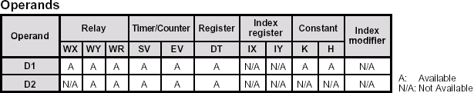

Explanation of example
The program shows an example in which initial values are set, and when the target value is 0, R50 goes on. When the leading edge of reset trigger X2 is detected (OFF   ON), “0” is transferred to data register DT0. Then the trailing edge of X2 is detected (ON   OFF) and data in word internal relay WR0 is transferred to DT0.

One is added to DT0 when the trailing edge of count trigger X1 is detected (ON   OFF) while the UP/DOWN trigger X0 is in the ON state.(Up counter operation)

One is subtracted from DT0 when the leading edge of X1 is detected (OFF   ON) while X0 is in the OFF state.(DOWN counter operation)

Using the F60 (CMP) instruction, the data in DT0 is compared with K0.

If DT0 = K0, special internal relay R900B (= flag) turns ON and then internal relay R50 turns ON.

時序圖表 ( Time chart )
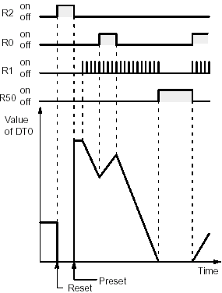
Description
The counter is switched between an incremental count (addition) or decremental count (subtraction) by turning the relay specified for up/down
input on or off.
When the up/down input is on, the incremental counter (+1) is effective, and when it is off, the decremental counter ( - 1) is effective. The duration value is stored in the area specified by the [D] parameter.
When the count input is switched from off to on (the reset input is in “Off” state), the value specified for the [D] parameter is initialized, and the counting
operation begins.
The preset value in S is transferred to D when the trailing edge of the reset trigger is detected (ON   OFF).
Set value range K-32,768 to K32,767 (H8000 to H7FFF)
The area for counter elapsed value D becomes 0 when the leading edge of the reset trigger is detected (OFF   ON).
The results of the counting operation can be determined by comparing the duration value of [D] with the specified value, using the data comparison
command.
The data comparison command should be executed immediately following execution of this command.

Flag conditions
- = flag (R900B): Turns ON for an instant when the elapsed value area D is recognized as “0”.
- Carry flag (R9009): Turns ON for an instant when the elapsed value area D exceeds the range of 16-bit data (K-32,768 to K- 1).

. Notes
- If the duration value memory area has been specified as a retention-type memory area, the duration value acts in
accordance with the contents being retained.
- D Please be aware that, when an operation is begun, the set values are not automatically preset to the duration value area.
To preset these values, the reset input must be switched from the “On” to the “Off” state.
- D If the F118 command is used in conjunction with the And Stack or the Pop Stack command, please be sure that it is
notated correctly.
- D With the F118 command, addition or subtraction begins when the count input is switched from the “Off” to the “On” state.
- As long as the count input continues to be on, counting is carried out only at startup. No subsequent counting is carried
out.
- D After switching to the “Run” state, and when the power supply is turned on in the Run mode, if the count input has been on
since the beginning, addition or subtraction will not be carried out for the first scan.

Counter trigger
Operation
No count done Count done
RUN
(Power: ON)
D When used in combination with instruction which change the order of instruction execution (see below), the operation of the instruction may change depending on the timing of instruction execution and the count input. Exercise caution in these cases.
- MC ~ MCE commands (see page 3 - 50.)
- JP ~ LBL commands (see page 3 - 53.)
- LOOP ~ LBL commands (see page 3 - 56.)
- CNDE command (see page 3 - 61.)
- Stepladder command (see page 3 - 62.)
- Subroutine command (see page 3 - 72.)

