功率真空管可使用其他型号，如FU-33
如果要做小功率的可以用此款变压器：
http://item.taobao.com/auction/item_detail-0db2-117d61fb0b24af882f4e3872471b6fba.htm?cm_cat=0
电源
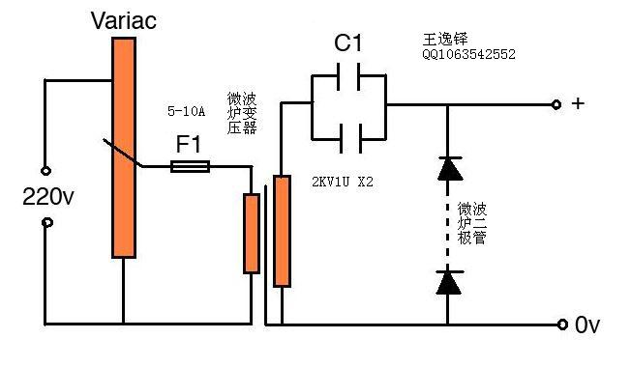
Transformer - Microwave oven transformer, 2100v output.变压器：微波炉变压器，2100v输出。
C1 - Two microwave oven capacitors, total value around 2uF. C1 -两个微波炉电容器，总容量约2uF。
D1 - Two microwave oven diodes in series. D1-两个微波炉微波二极管。
F1 - Variac protection fuse, around 5-10A.F1-保险丝，约5 - 10A。
This circuit has several different names - level shifter, voltage doubler etc. It outputs around twice the transformers voltage at halfwave dc, so I should be getting about 4-5kv out of it.该电路是倍压电路，输出是输入两倍左右，半波直流的电压，所以输出大约4-5kV。
原文：
http://www.davekearley.co.uk/TeslaCoil/VTTC%20TankCapacitor.html

翻译:
http://203.208.37.132/translate_c?hl=zh-CN&sl=en&u=http://www.davekearley.co.uk/TeslaCoil/VTTC%2520TankCapacitor.html&prev=/search%3Fq%3DVTTC%2Btesla%26hl%3Dzh-CN%26newwindow%3D1&rurl=translate.google.cn&usg=ALkJrhiHLguQnjltTBPJ6OrvWhVNKL8bCA

主电路
返回目录
Following some further research, I have decided to try this circuit first as the one shown at the end of the page seems to be a bit radical in it's design and probably not for suitable raw beginners.以下是一些进一步的研究，我决定试试这个电路。
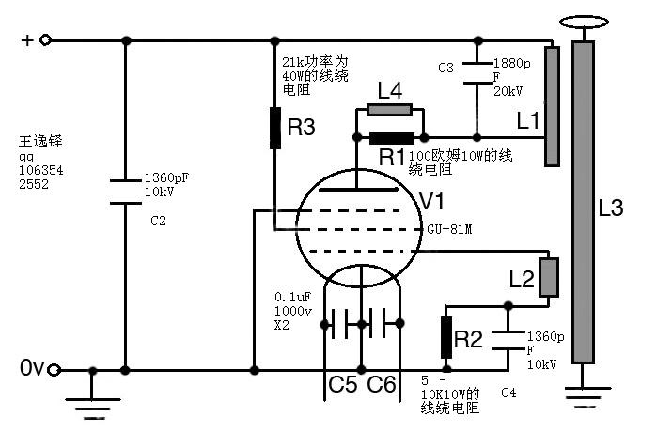
C2 - Filter cap, 1360pF 10kV ceramic.C
吧

C2，1360pF 10kV的陶瓷电容。
C3 - Tank cap, 1880pF 20kV ceramic.C3 –电容组，1880pF 20kV陶瓷电容（大功率）。
C4 - Grid cap, 1360pF 10kV ceramic. C4 -1360pF 10kV的陶瓷电容。
C5\C6C5 / C6 - Filament filters, 0.1uF 1000v polypropylene.C5/C6-滤波电容，0.1uF 1000v聚丙烯电容。
L1L1 - Primary coil, 25 turns insulated wire on a 150mm former.L1-初级线圈，25圈，绕在150毫米管子上。
L2L2 - Feedback coil, 20 turns insulated wire on a 150mm former,LL-反馈线圈，20圈，绕在150毫米管子上，
两个线圈间距mounted 1cm below the primary coil, moveable for tuning.两个线圈艰巨1厘米，可调整。
L3L3 - Secondary coil, 1000 turns 0.315mm wire on a 68mm former.L3-二次线圈，1000圈，绕在直径68毫米的管子上，用0.315毫米漆包线。
L4L4 - Anode choke inductor, 10 turns close wound on R1.LL-阳极扼流电感，10圈。
R1 - Anode choke resistor, 100R 10W wirewound. R1 -阳极电阻，100欧姆10W的线绕电阻。
R2 - Grid leakage resistor, 5-10k 10W wirewound. R2-5 – 10K10W的线绕电阻。
R3 - Screen bias resistor, 21k 40W wirewound. R3-偏置电阻，21k功率为40W的线绕电阻。
V1 - GU-81M Tube. V1 – GU-81M。
In the circuit above, the tube is wired as a pentode.

CIRCUIT TWO第二种电路
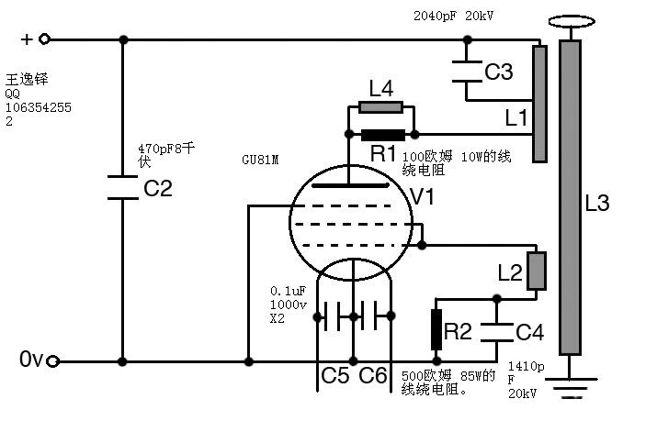
C2 - Filter cap, 470pF 8kV ceramic.C2- 470pF8千伏的陶瓷电容。
C3 - Tank cap, 2040pF 20kV ceramic.C3 –电容组，2040pF 20kV陶瓷电容。
C4 - Grid cap, 1410pF 20kV ceramic. C4 - 1410pF 20kV的陶瓷电容。
C5\C6-滤波电容C5 / C6 - Filament filters, 0.1uF 1000v polypropylene.C，0.1uF 1000v的聚丙烯电容。
L1L1 - Primary coil, 48 turns insulated wire.L1-初级线圈，48圈 用绝缘电线绕。
L2L2 - Feedback coil, 21 turns insulated wire.L-反馈线圈，21圈 用绝缘电线。
L3L3 - Secondary coil, 1000 turns 0.25mm wire on a 68mm former.L-二次线圈，1000圈，直径68毫米的管子0.25毫米粗的漆包线。
L4L4 - Anode choke inductor, 10 turns close wound on R1.L4-阳极扼流电感，10圈。
R1 - Anode choke resistor, 100R 10W wirewound. R1 -阳极电阻，100欧姆 10W的线绕电阻。
R2 - Grid leakage resistor, 500R 85W wirewound. R2-500欧姆 85W的线绕电阻。
V1 - GU-81M Tube. V1-GU81M。
In this circuit, the tube is wired as a triode and not a pentode, this makes it a bit easier to set up.在此电路，GU81M作为三极管，而不是五级管，这使得有些参数被更改了。 The center tap of the filament is grounded to the RF ground system along with the base of the secondary and the zero volt supply rail.该中心抽头的灯丝接地。
原文：
http://www.davekearley.co.uk/TeslaCoil/VTTC%20The%20main%20circuit.html
翻译：http://203.208.37.132/translate_c?hl=zh-CN&sl=en&u=http://www.davekearley.co.uk/TeslaCoil/VTTC%2520The%2520main%2520circuit.html&prev=/search%3Fq%3DVTTC%2Btesla%26hl%3Dzh-CN%26newwindow%3D1&rurl=translate.google.cn&usg=ALkJrhhhT0GcYUcyOmN-UA-74ZZZn7A9dA

他用的电容（C3）
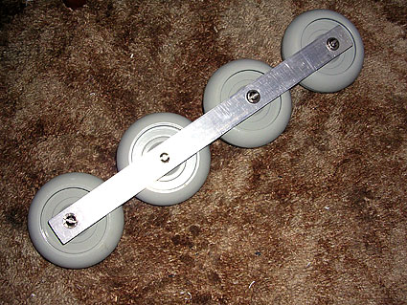
Four 470pF 20kV 60kVAr Capacitors, connected in parallel for a total value of 1880pF.四个470pF 20kV 60kVAr电容器，并联，总容量1880pF。 They are quite large, the total length of the unit is around 420mm and weighs around 2kg !他们相当大，总长度约四百二十毫米，有2公斤左右的重量！
I have connected them with 25mm x 1.5mm aluminium strips, hopefully they will be big enough for the job but who knows !!我已用铝带来连接（25毫米x 1.5毫米）他们，希望他们有足够大的工率，但不能肯定！
原文：
http://www.davekearley.co.uk/TeslaCoil/VTTC%20TankCapacitor.html
翻译：
http://203.208.37.132/translate_c?hl=zh-CN&sl=en&u=http://www.davekearley.co.uk/TeslaCoil/VTTC%2520TankCapacitor.html&prev=/search%3Fq%3DVTTC%2Btesla%26hl%3Dzh-CN%26newwindow%3D1&rurl=translate.google.cn&usg=ALkJrhiHLguQnjltTBPJ6OrvWhVNKL8bCA
赠送其他VTTC电路图一张：
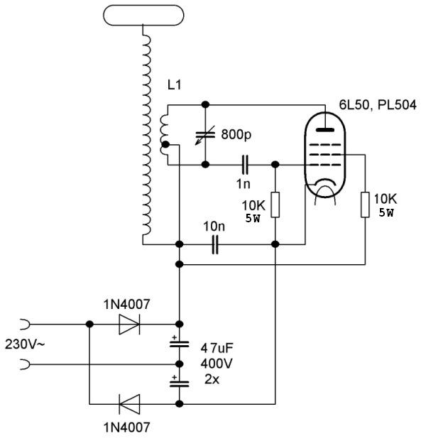

更多内容：
http://translate.google.com/translate?hl=zh-CN&sl=en&u=http://www.davekearley.co.uk/TeslaCoil/VTTC%2520TankCapacitor.html&prev=/search%3Fq%3DVTTC%2Btesla%26hl%3Dzh-CN%26newwindow%3D1&rurl=translate.google.cn

http://translate.google.com/translate?hl=zh-CN&sl=en&u=http://www.davekearley.co.uk/TeslaCoil/VTTC%2520TankCapacitor.html&prev=/search%3Fq%3DVTTC%2Btesla%26hl%3Dzh-CN%26newwindow%3D1&rurl=translate.google.cn
http://translate.google.com/translate?hl=zh-CN&sl=en&u=http://www.davekearley.co.uk/TeslaCoil/VTTC%2520TankCapacitor.html&prev=/search%3Fq%3DVTTC%2Btesla%26hl%3Dzh-CN%26newwindow%3D1&rurl=translate.google.cn

http://translate.google.com/translate?hl=zh-CN&sl=en&u=http://www.davekearley.co.uk/TeslaCoil/VTTC%2520TankCapacitor.html&prev=/search%3Fq%3DVTTC%2Btesla%26hl%3Dzh-CN%26newwindow%3D1&rurl=translate.google.cn

以下内容全部复制粘贴！
我的振荡器驱动器真空管特斯拉线圈
设计规范
返回目录
+++Primary Coil+++ + + +初级线圈+ + +
25 Turns 2.5mm copper cable wound on a 15cm former. 25打开2.5毫米铜线上15厘米的伤口前。
+++Secondary Coil+++ + + +二次线圈+ + +
1000 turns of 0.315mm enammelled copper wire on a 10000.315毫米enammelled铜线打开一
68mm pvc former. 68毫米聚氯乙烯前者。
+++Oscillator+++ + + + + + +振荡器
Variable between 150 & 500kHz, 300v pp output.介于150和为500kHz，300v可变页输出。
+++Power Supply+++ + + +电源供应器+ + +
2.1kV 1300W Microwave oven transformer for the main tube plate supply 2.1kV 1300W微波炉变压器的主要管板供应
2.1kV 1300W Microwave oven transformer for the main tube screen grid supply 2.1kV 1300W微波炉变压器的主要供水管网屏
12v 12A Transformer for the main tube heater supply 12伏12A条变压器的主要供应管加热器
240v + 6.3v Transformer for the oscillator and grid bias 240伏+ 6.3V的的振荡器和网格偏见变压器
+++Tank Capacitor+++ + + +背心电容+ + +
1880pF 20kV Ceramic capacitor rated at 60kVAr 1880pF 20kV陶瓷电容器额定电压为60kVAr
+++Control Box+++ + + +控制盒+ + +
Standard line filter at input, earthed to supply ground标准的输入线滤波器，接地供应地
275v MOV across supply outputs 275v检验手段在供应产出
Variac power control调压功率控制
Input 'Live' and 'Ready to fire' warning lamps输入'活'和'随时提供火灾的警告灯
Output voltage and current meters输出电压和电流米
Key operated safety switch重点经营的安全开关
Two simultaneous press-to-fire buttons两个同时按到火灾按钮
and a long extension lead !!扩展和长期领先！
经过广泛的研究和来自建筑工地的特斯拉线圈的成员，帮助英国的很多，我已经提出了下面的电路。
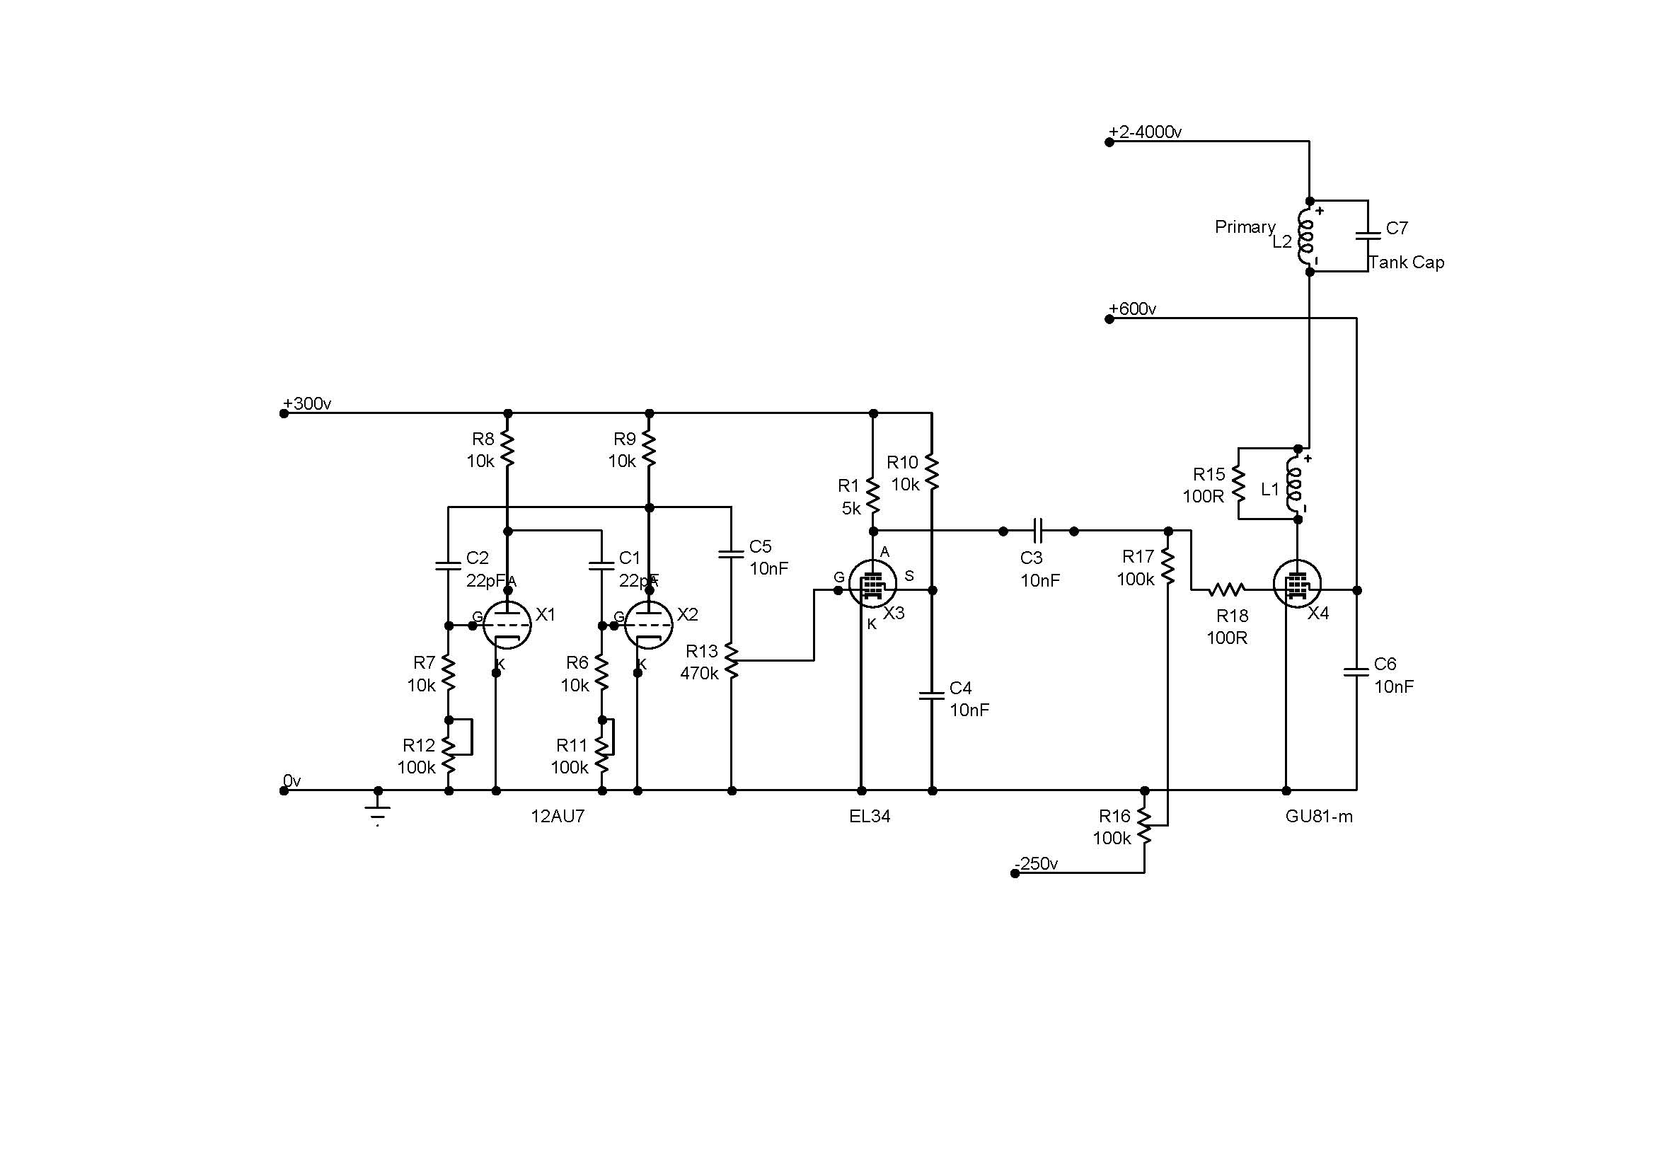
在电源电路
返回目录
的电源
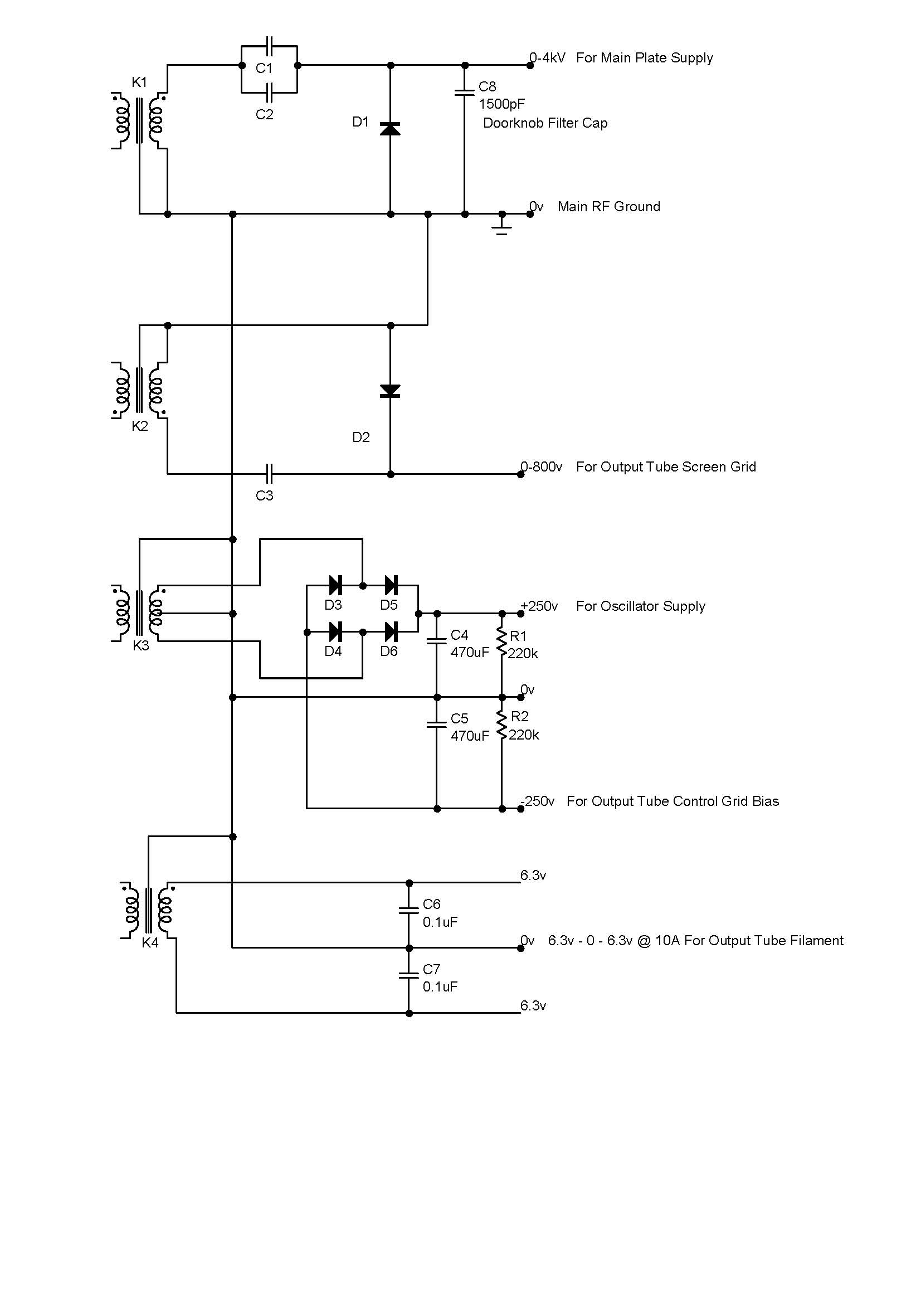
K1 / K2 - Microwave oven transformers, 2100v output. K1 /幼-微波炉变压器，2100v输出。
K3 - Mid power supply transformer for Oscillator, grid bias and small tube heaters. K3的-中功率振荡器，网格偏见和小管加热器电源变压器。
K4 - 12.6v 10A Filament transformer for output tube. K4 - 12.6V的输出10A条管灯丝变压器。
C1 / C2 / C3 - Microwave oven capacitors. C1 /为C2 /选项C3 -微波炉电容器。
D1 / D2 - Microwave oven diodes. D1的/ D2 -微波炉二极管。
C4 / C5 - 470uF Smoothing Capacitors. C4 /碳五- 470uF平滑电容器。
C6 / C7 - 0.1uF Filament Decoupling Capacitors.型2号/威盛C7 - 0.1uF丝去耦电容。
R1 / R2 - 220k Bleeder Resistors. R1 / R2的- 220,000分压电阻。
D3 / D4 / D5 / D6 - 1N4007 Rectifier Bridge.维生素D3 / D4类/ D5 / D6级- 1N4007整流桥。
Yes, thats 4 large and heavy power transformers !是的，多数民众赞成4个大型和重型电力变压器！ K1 & K2 are supplied via individual variacs so I can control the output tube parameters fully. K1及幼是通过提供个人variacs这样我就可以控制输出管参数充分。 The bleeder resistors are there for my safety while testing.该排放口的电阻为我的安全，同时也测试。 Should suck a few watts when I power the beast up :-)如果吸几瓦，当我的权力野兽了:-)

法官设置...
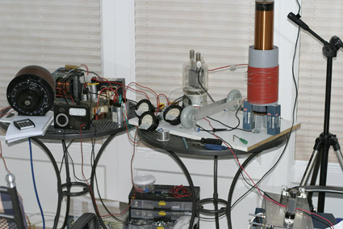
On the left is the power supply area, two 2100v microwave oven transformers, a 12v 12A heater transformer, level shifter diodes, capacitors and one of the control variacs.在左边的是电力供应方面，2 2100v微波炉变压器，一个12V 12A条加热器变压器，电平转换二极管，电容器和控制variacs之一。
Bottom right hand corner shows the oscillator unit, top right hand is the primary and secondary coils.右下角显示了振荡器的单位，最右边是小学和中学线圈。
In the middle is the main tube, tank capacitors, filter capacitors and power meters for plate volts and current and screen-grid volts and current.在中间是主要的管，罐电容，滤波电容和电压和电流板和屏幕电网电压和电流功率计。
This birds-nest lash-up is easily capable of putting out enough power to kill so it has to be treated with the utmost respect, you really will only get one chance when mucking with this sort of power!!这种鸟类巢睫毛行动能够很容易出足够的力量将杀死，所以要以最大的尊重对待，你真的会只有一次机会时，这种权力的这类起重机！ Then there is the fire risk and so-on, it's not a past-time to be taken lightly.然后是火灾的风险等对，它不是过去，时间掉以轻心。
坦克电容器
返回目录
Four 470pF 20kV 60kVAr Capacitors, connected in parallel for a total value of 1880pF.四470pF 20kV 60kVAr电容器，并联为1880pF的总价值。 They are quite large, the total length of the unit is around 420mm and weighs around 2kg !他们是相当大，该单位的总长度约四百二十毫米和2公斤左右的重量！
I have connected them with 25mm x 1.5mm aluminium strips, hopefully they will be big enough for the job but who knows !!我已连接25毫米x 1.5毫米铝带他们，希望他们将足够大的工作，但谁知道！
结果
返回目录
22/08/2005 - Further tuning. 22/08/2005 -进一步调整。
I gave the coil a lengthy run to see if anything blew up, and it didn't !我给线圈一个漫长的运行是否有任何爆炸，并没有！
Then it was time for a full power run, chair was moved back a bit :-) and the knobs were all twiddled to their relative maximum settings, it's not simply just a matter of whacking them all up to max, as this power supply could easily blow the tube.然后是一个全功率运行时，椅子向后移动了一点:-)和旋钮都twiddled其相对最高的设置，这不是简单的重击只是把他们全部的最大问题，因为这可供电轻松地打击管。
The output was nice and hot and noisy with 3 - 4 inch streamers. But overall it was not realy good enough considering that the setup was burning a horrendous amount of mains power !输出是好的和热和噪音，3 - 4英寸的标语。但整体而言，并没有真正足够考虑到安装在燃烧的主电源可怕的金额！ Time for some fine tuning.当时一些微调。
The primary coil was raised up 2 inches and the connections reversed.初级线圈有人提出了2英寸和连接扭转。 This time it managed 4 - 5 inch, sword-like streamers using much less power, so I can eventually push it even further.这一次，管理的4 - 5寸，剑就像使用的功率小得多飘带，因此，我可以最终推进一步。 The downside was that it made it harder to adjust the oscillator into resonance, but is was still possible and, once there it was stable.其缺点是，它使得难以调整到共振振荡器，但仍有可能，而且一旦有它是稳定的。
This was much more satisfying, it was also much louder !这是更令人满意的，但也很响亮！
The radiating power of this coil is quite impressive too, an open oscilloscope lead can easily pick up 50v of radiated RF power at over three feet away, fluorescent tubes glow brightly two feet away and my calculator blew itself up while I was sitting there trying to work out the power figures !这个线圈辐射能力相当惊人，也是一个开放的示波器领导可以轻松地拿起了辐射射频功率50v超过3英尺远，焕发明亮的光管两英尺距离，我的计算器本身炸毁了，而我坐在那里，试图制定电力数字！ (sadly, it never recovered) （可悲的是，再也没有恢复过来）
This is basically an AM radio transmitter, which bungs out large amounts of noise at around 450kHz, so it's probably not a good idea to run it for long periods :-)这基本上是一个AM广播发射机，其中bungs了约450kHz大量的噪音，所以它可能不是一个好Tctc
设计规范
返回目录
Following lengthy research on the web and with the kind help of the members of经过长时间的研究网络，并与各成员一种帮助
, 特斯拉线圈建设者英国 ，
I managed to conjure up a reasonably easy to build design using readily available parts.我设法营造了轻松构建合理的设计，使用现成的零件。
+++Primary Coil+++ + + +初级线圈+ + +
12 turns 8mm copper tube 12转8毫米铜管
Outer Diameter - 606mm外径-六零六毫米
Inductance - 0 to 64uH电感- 0至64uH
+++Secondary Coil+++ + + +二次线圈+ + +
Core material - 110mm grey pvc pipe核心材料- 110毫米灰色PVC管材
Wire - 0.5mm enammelled copper丝- 0.5毫米enammelled铜
Winding height - 550mm绕组高度- 550毫米
Overall height - 650mm总高度- 650毫米
Turns - 1000打开- 1000
Inductance - 19.865mH电感- 19.865mH
Capacitance - 8.394pF电容- 8.394pF
Resonant frequency - 239kHz共振频率- 239kHz
Insulation - 3 heavy coats of polyurethane varnish绝缘- 3聚氨酯清漆厚重的外套
+++Power Supply+++ + + +电源供应器+ + +
10kV 50mA Neon sign transformer 10kV的50mA的霓虹灯变压器
Standard line filter at transformer supply, earthed to RF ground标准的变压器供电线路滤波器，射频接地接地
Power factor correction - 25uF 440v功率因数校正- 25uF 440v
275v MOV accross supply 275v检验手段在供应
Custom R/C filter in HT lines to main spark gap定制R / C的羟色胺线过滤器主要火花隙
Safety spark gap across transformer output, centre electrode to RF ground安全火花输出变压器上的差距，中心电极射频接地
+++MMC Tank Capacitor+++ + + + MMC管理背心电容+ + +
Value - 16.7nF at 21kv价值- 16.7nF在21kv
Made up of 5 strings of 14 * 0.047uF 1500v组成5 14 * 0.047uF 1500V的字符串
polypropylene capacitors聚丙烯电容器
+++Control Box+++ + + +控制盒+ + +
Standard line filter at input, earthed to supply ground标准的输入线滤波器，接地供应地
275v MOV across supply outputs 275v检验手段在供应产出
Variac power control调压功率控制
Input 'Live' and 'Ready to fire' warning lamps输入'活'和'随时提供火灾的警告灯
Output voltage and current meters输出电压和电流米
Key operated safety switch重点经营的安全开关
Two simultaneous press-to-fire buttons两个同时按到火灾按钮
and a long extension lead !!扩展和长期领先！
初级线圈
返回目录
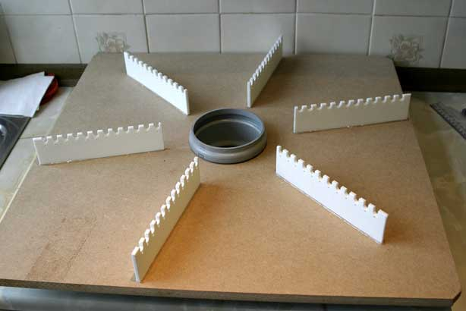
The base assembly prior to varnishing etc. The coil supports are made from HDPE (chopping boards) and were cut on a table saw which worked quite well.该基地集之前，光油等线圈支持均是从高密度聚乙烯（砧板），并在表上看到这些切得很不错。 I fixed them to the MDF base using a hot-melt glue gun.余定他们的中密度纤维板基地使用热熔胶枪。
The grey socket in the middle is the end of my coil former pipe with the rubber ring seal removed to make assembly easier.中间灰色插座是我线圈与橡胶圈密封管端前删除，以便组装容易。
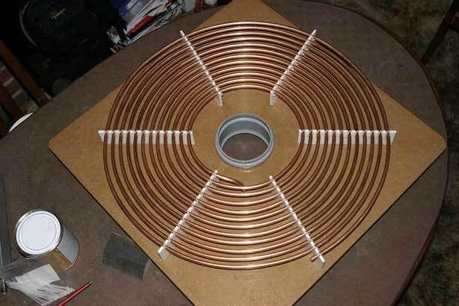
The finished primary coil.完成的初级线圈。 The base had three coats of varnish. The copper pipe is held in place by miniature nylon cable ties, there are no metal fixtures at all in this area.该基地有三个清漆底漆。铜管到位举行小型尼龙扎带，有没有任何这方面的金属装置。
电容器
返回目录
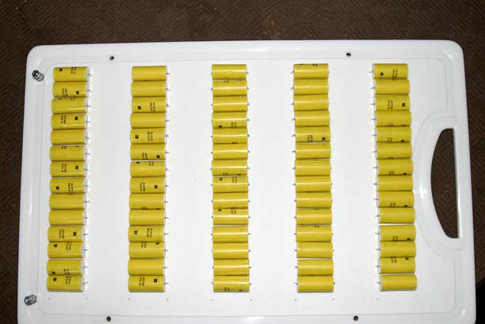
Front view, 70 x 0.47uf 1500v caps in five strings of 14 to give a value of 16.7nf at 21000v.阵线认为，在5月14串70 × 0.47uf 1500V的上限，让在21000v的16.7nf价值。
Looks like a chopping board, but really it's a high voltage circuit board !像砧板外观，但实际上它是一个高压电路板！
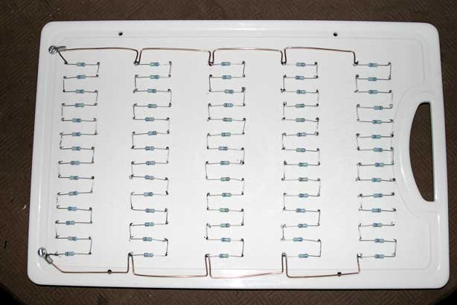
Back view, 70 x 10M 0.5W hv resistors to discharge the possibly lethal power stored after switching off.背面，70 x 10米高压电阻为0.5W履行可能是致命的电源关掉后储存。
The row connecting 'bus bars' are 2.5mm solid copper cable.该行接驳巴士酒吧'是2.5毫米固体铜电缆。
20/01/2004 - Ammendment - Following some more research, I have now doubled the size of the bus bars by soldering another 2.5mm wire along the existing ones. 20/01/2004 -修订-以下一些调查研究，我现在已经翻番，另一辆由焊接现有的2.5毫米线材的母线的大小。 Although only for a very brief period, the currents flowing during discharge can easily reach 100A !虽然只在很短的时间，在放电的电流流动可以方便地到达100号A！ and any resistance equals lost power.和任何电阻等于失去了动力。

输入滤波器
返回目录
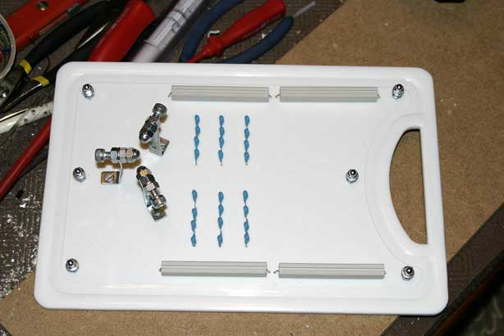
Input filter Mk1, on the left is my adjustable safety gap with the centre electrode grounded, top and bottom are two 470 ohm 30W wirewound resistors in series on each 5kV leg, the small blue blobs are 1000pF 3kV caps in a mini MMC setup giving a total of 750pF at 12kV to ground on each supply leg.输入滤波器Mk1左边，是我与中心电极间隙可调安全基础，顶部和底部是两个470欧姆功率30W在每个5kV的脚系列线绕电阻器，这种蓝色的小斑点是1000pF的千伏的小型MMC中提供一个安装帽总的750pF地面12kV的每个供应站。
I have a feeling that i'll be letting the smoke out of this board first !!我有一种感觉，我将让这个委员会第一次出的烟雾！
(in a scientifically controlled manner of course) （当然，在科学控制方式）
电源和主要差距
返回目录
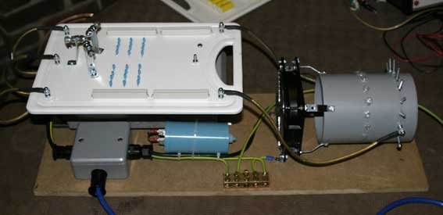
Pictured above is my completed power supply board.图为以上是我完成电源板。 The input filter and safety gap board sits on top of the neon sign transformer.输入过滤器和安全差距董事会成员对霓虹灯变压器的顶部。 The small grey box (lower left corner) is the supply junction box and also houses the second mains line filter and MOV.灰色的小方块（左下角），是供应接线盒和还设有第二个电源线滤波器和MOV。 The blue tube is the 25uF power factor correction capacitor.蓝色管是25uF功率因数校正电容器。 Front centre is the main RF earthing bar and on the right is the main spark gap (detailed below).接待中心是主要的射频接地栏，右边是主要的火花隙（下文详述）。
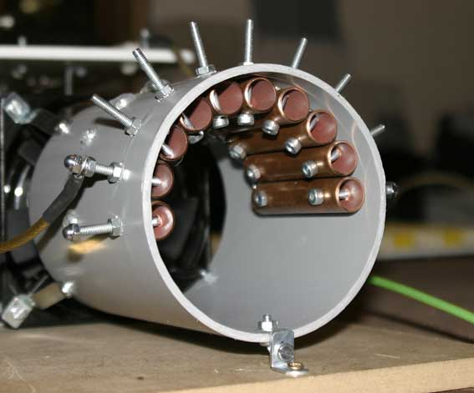
The main spark gap.主要的火花隙。 The tube is 110mm pvc about 200mm long. The pipes are 15mm x 75mm copper with 0.5mm gaps between each.管是110毫米聚氯乙烯约200毫米长。用的管道每年0.5毫米之间的差距15毫米x 75毫米铜。 The bolts sticking out of the top are the variable tapping points for altering the power output of the coil.螺栓露出最上层是可变的挖掘，改变线圈的输出功率指出。 At present, it runs best at the highest setting but one.目前，它运行在最高的最佳设置只有一个。 At the rear of the tube is the quenching / cooling fan.在管后方是淬火/冷却风扇。
I believe this type of gap is named after it's creator, Richard Quick and are usually just called 'RQ' style gaps.我相信，这种差距类型的名字命名，它的创始人Richard快速，通常就叫做'智商'风格的差距。
在Topload和线圈一起
返回目录
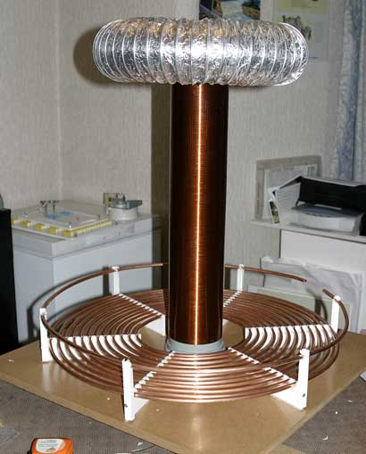
The first topload sitting atop of my coil, it will eventually be smoothed out with aluminium foil tape.第一topload之上坐在我的线圈，它最终会被理顺与铝箔胶带。
I have now added the strike rail above the primary coil to give a bit more protection against stray arcs.我现在已经加入了以上的初级线圈铁路罢工让多一点对流浪弧保护。
The secondary coil can be raised about 35mm above it's lowest position for tuning purposes.次级线圈可以提高约35毫米以上是最低的位置调整的目的。
全文完

